Integration of Via and Canvas Instructions for Faculty and Students
August 2019

Faculty Instructions To Link Via and Canvas
1. Click on the chain link icon on the right side of the page
2. Copy the link that is displayed.
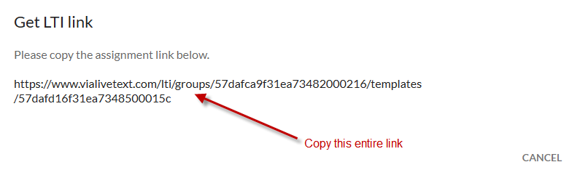
3. Login to your Canvas faculty account and navigate to your Course home page
4. Go to Assignments
5. Click "+ Assignment" to add a new assignment
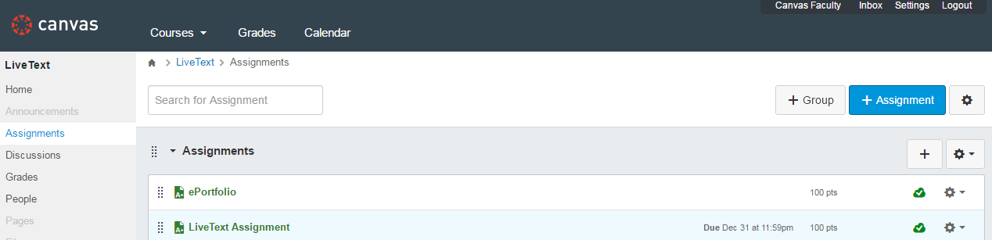
6. Enter a Title for your assignment
7. Enter a point value
8. Set Submission Type to External Tool
9. In the External Tool URL box, paste in the Activity link from Via
10. Click "Save & Publish"
11. The student or faculty member will need to click on the link to continue to Via.
12. Once the student completes the activity the student will move into the "In Assessment" column. As faculty Click on the blue edit pencil on the student's submission. This blue edit pencil will be available when you mouse over the lower right corner of their submission.
13. The score will be displayed in your assessment on Via
14. Once you have completed the assessment the student will move to the "Done" column.
15. The score will also be reflected in your Canvas gradebook effectively returning the grade from Via

Adding links to the In Progress, Timeline, and Showcases pages
If you would like to add links in Canvas that bring faculty and students to their In Progress, Timeline, or Showcases pages in Via, please enter the URLs below in place of the assignment URL:
In Progress: https://www.vialivetext.com/lti/sso/inprogress
Timeline: https://www.vialivetext.com/lti/sso/timeline
Showcases: https://www.vialivetext.com/lti/sso/showcases

Student Instructions
1. Log into your Canvas account
2. Navigate to your course's Assignments page
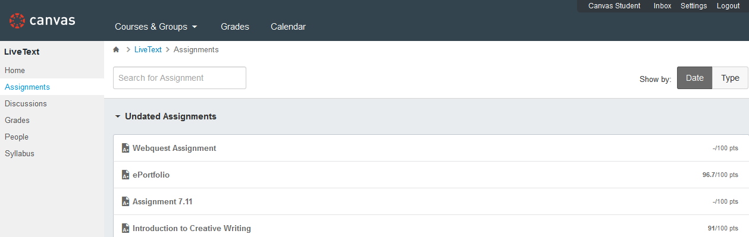
3. Click on the link for your assignment. If you have not accessed Via through a link in Canvas before and the institution has not provided your Canvas ID in Via, you will first need to enter in your email address and password for Via.
*******PLEASE LOG INTO VIA AT THIS POINT*******
4. You will then be brought to the assignment submission page in Via
