You can join a Microsoft Teams Meeting in 1 of 2 ways:
Method 1
Step 1: Open you Eagle Email and click on the icon for your outlook calendar.
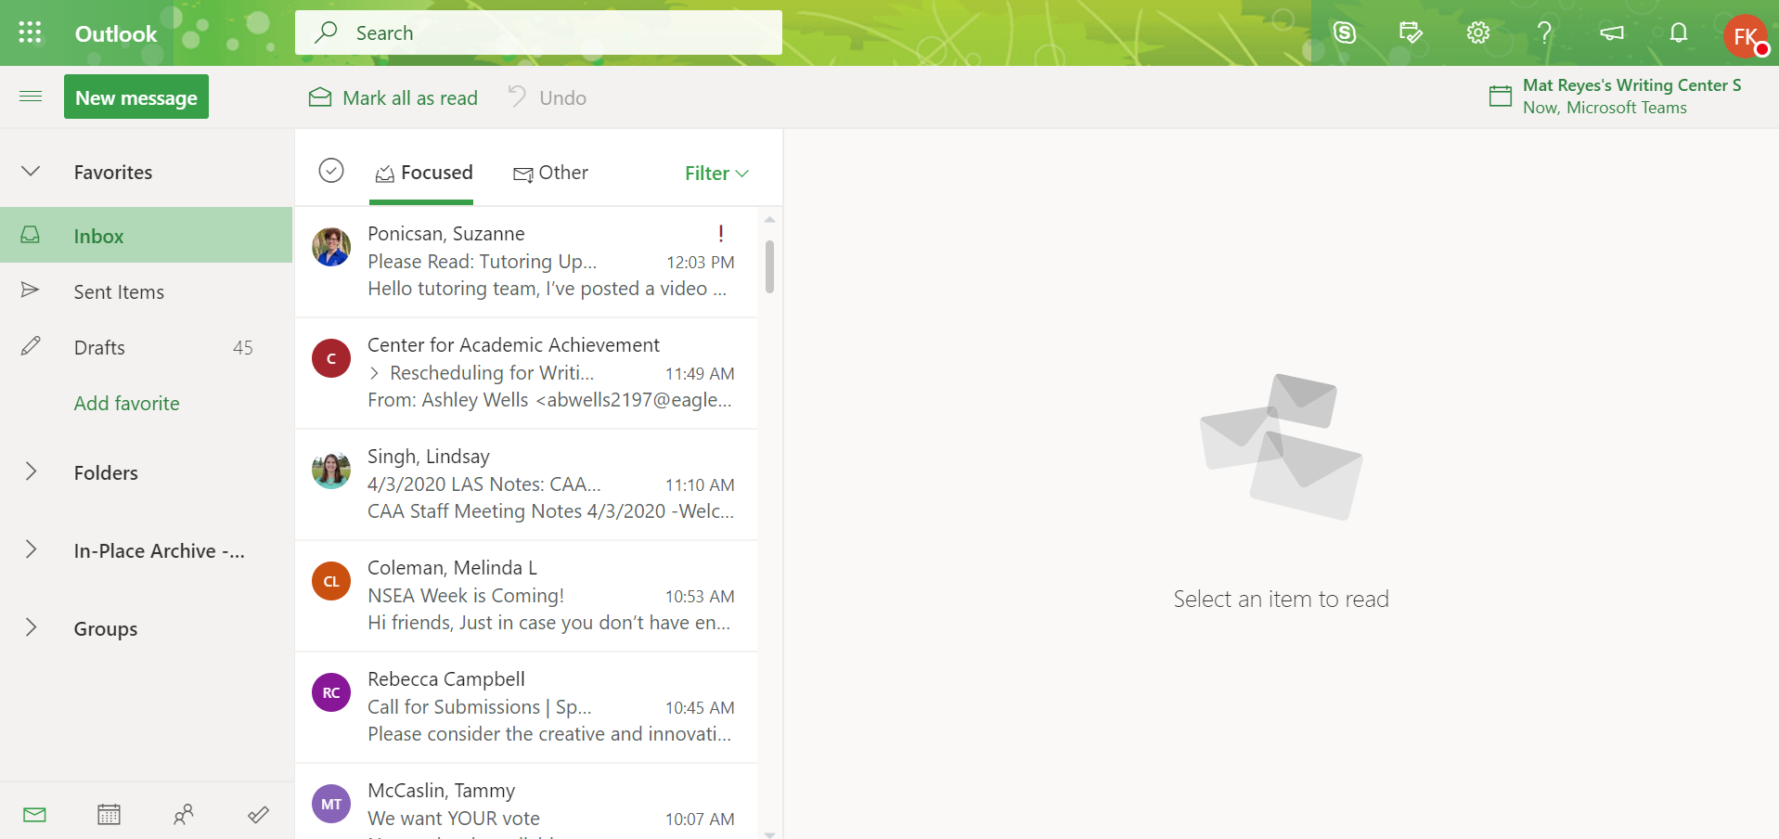
Step 2: Double click on the appointment on your calendar. This will open the appointment.
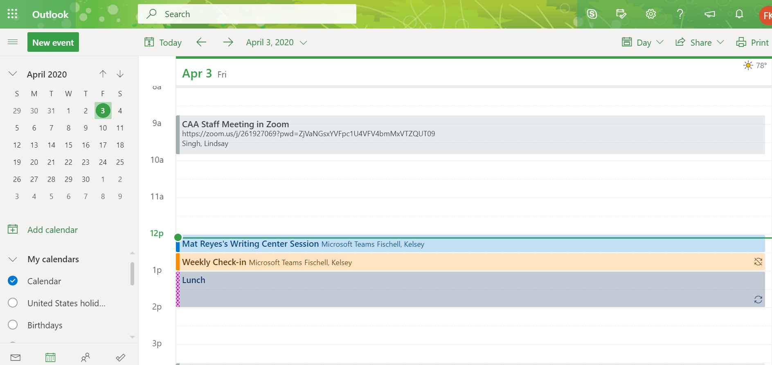

Step 3: Click on the “Join Microsoft Teams Meeting” link in the appointment information.
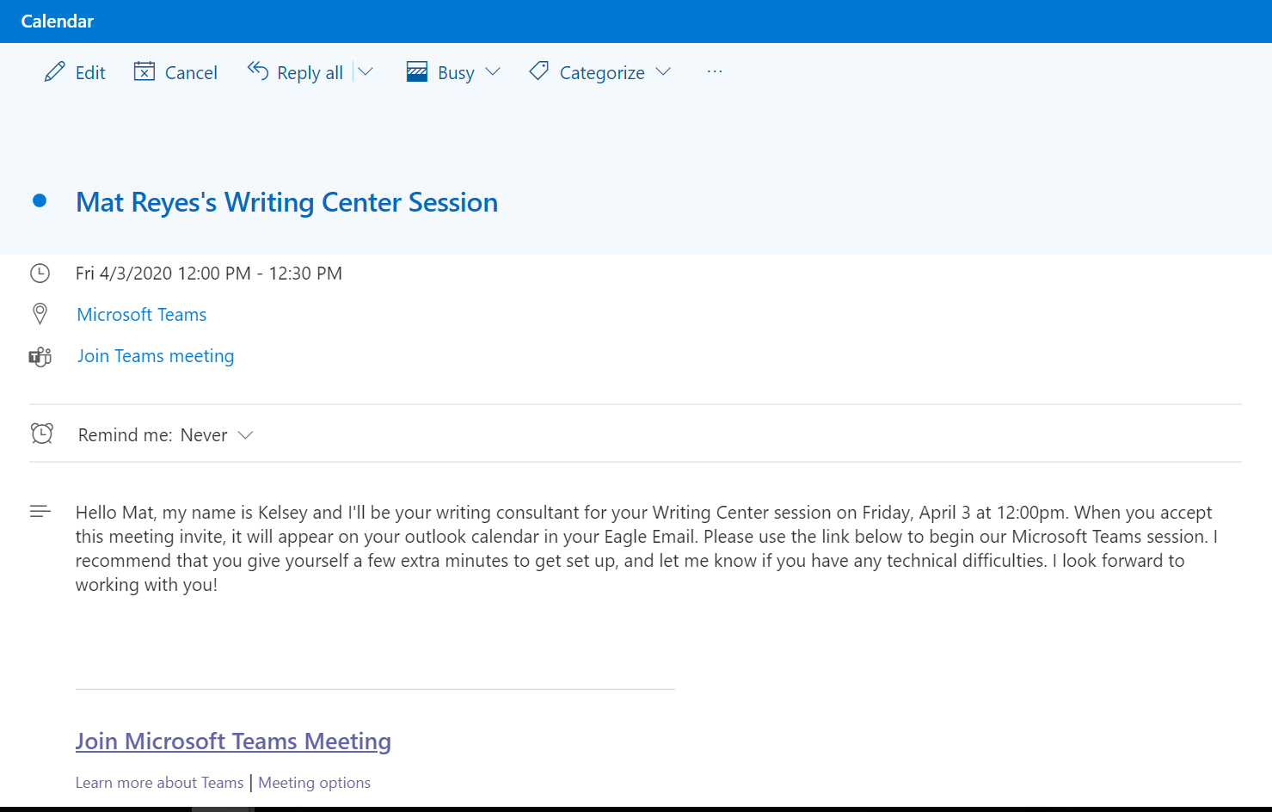

Step 4: The window asking you to join the chat will appear (you may first be asked whether you want to join the conversation using the web browser or by downloading the app—choose the option that is best for you).
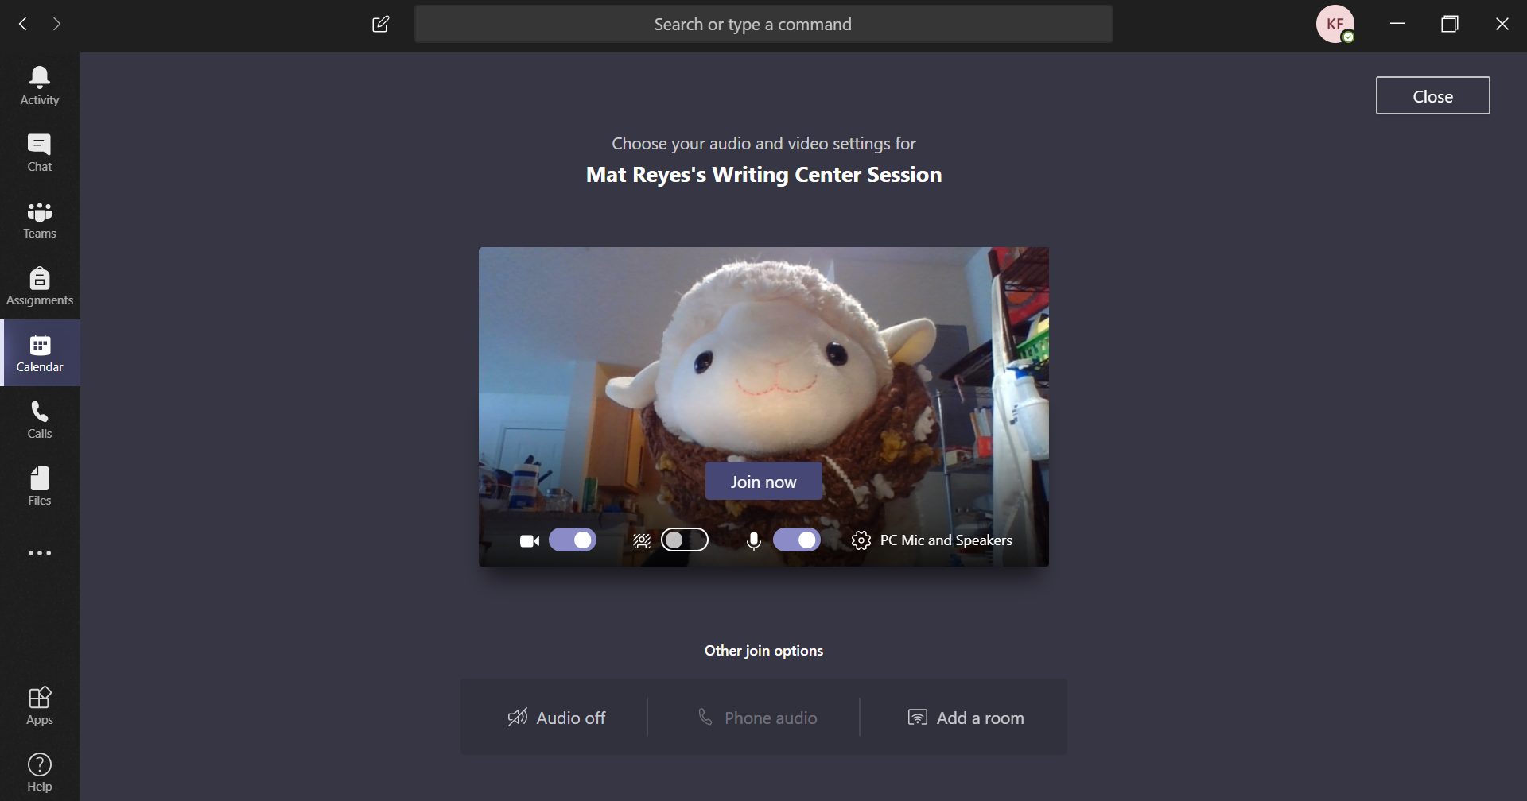’

Method 2:
Step 1:
Step 1: Log into Microsoft Teams. From here, go to the “Calendar” option on the left-hand menu.
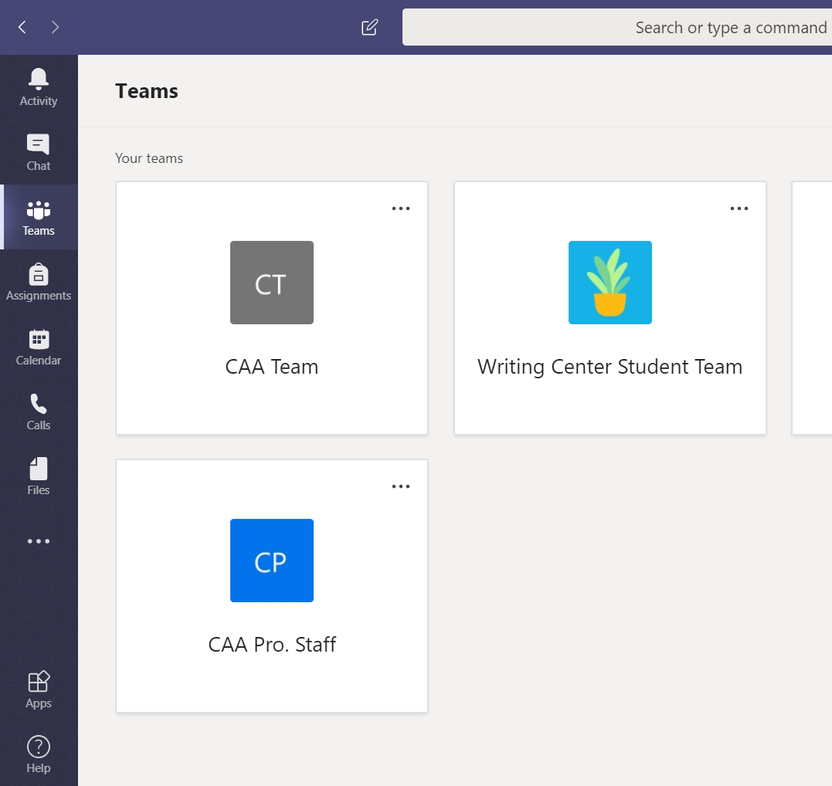
Step 2: Find the session appointment on your calendar. Double-click to open the appointment.
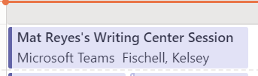

Step 3: In the appointment, click the “Join” button to join the session.
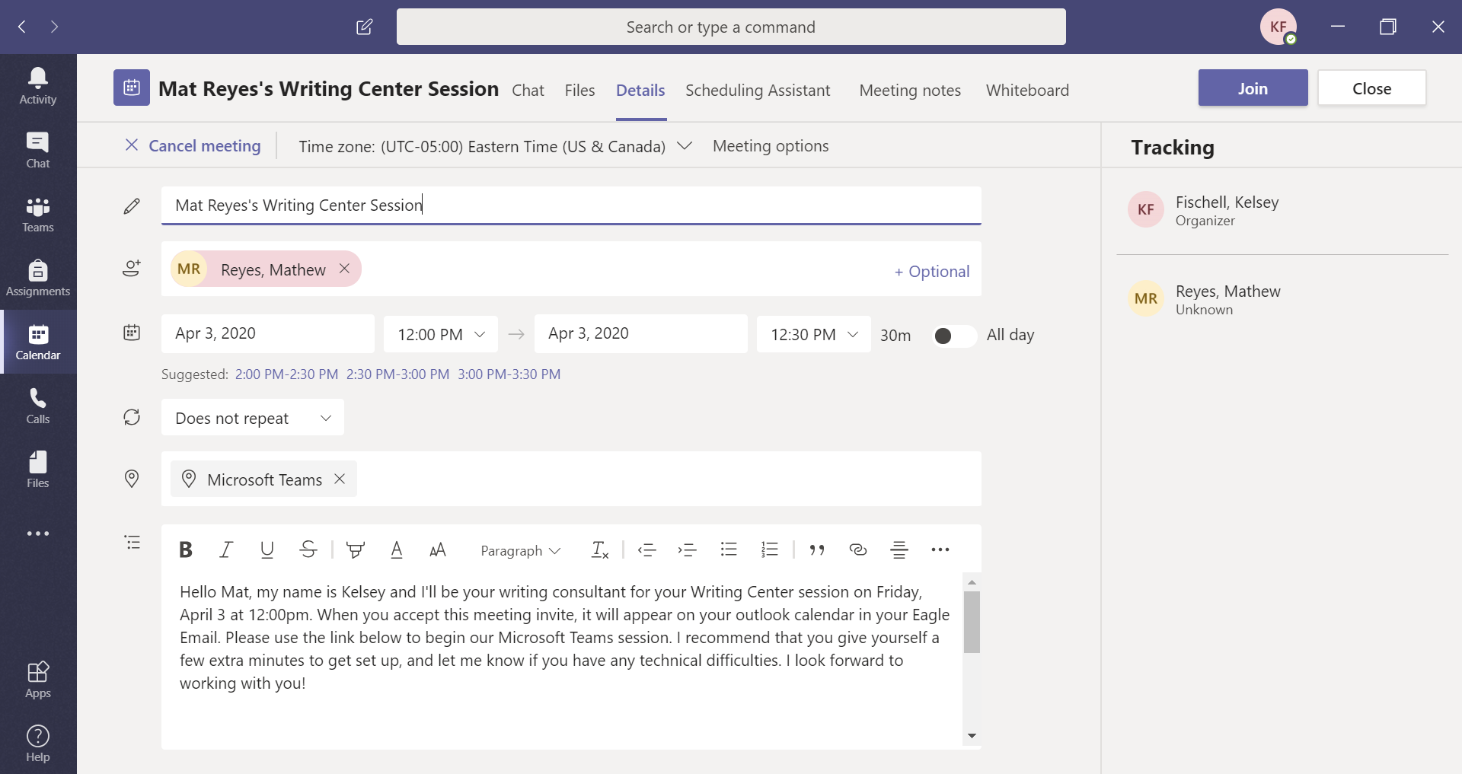
Step 4: The window asking you to join the chat will appear (you may first be asked whether you want to join the conversation using the web browser or by downloading the app—choose the option that is best for you).
’

