Downloading Microsoft Teams App
Step 1: Log into your eagle email account at https://www.fgcu.edu/its/students/student-welcome
Step2: Locate the Apps selection button on the top left corner of your page (it looks like a grid of 6 dots)

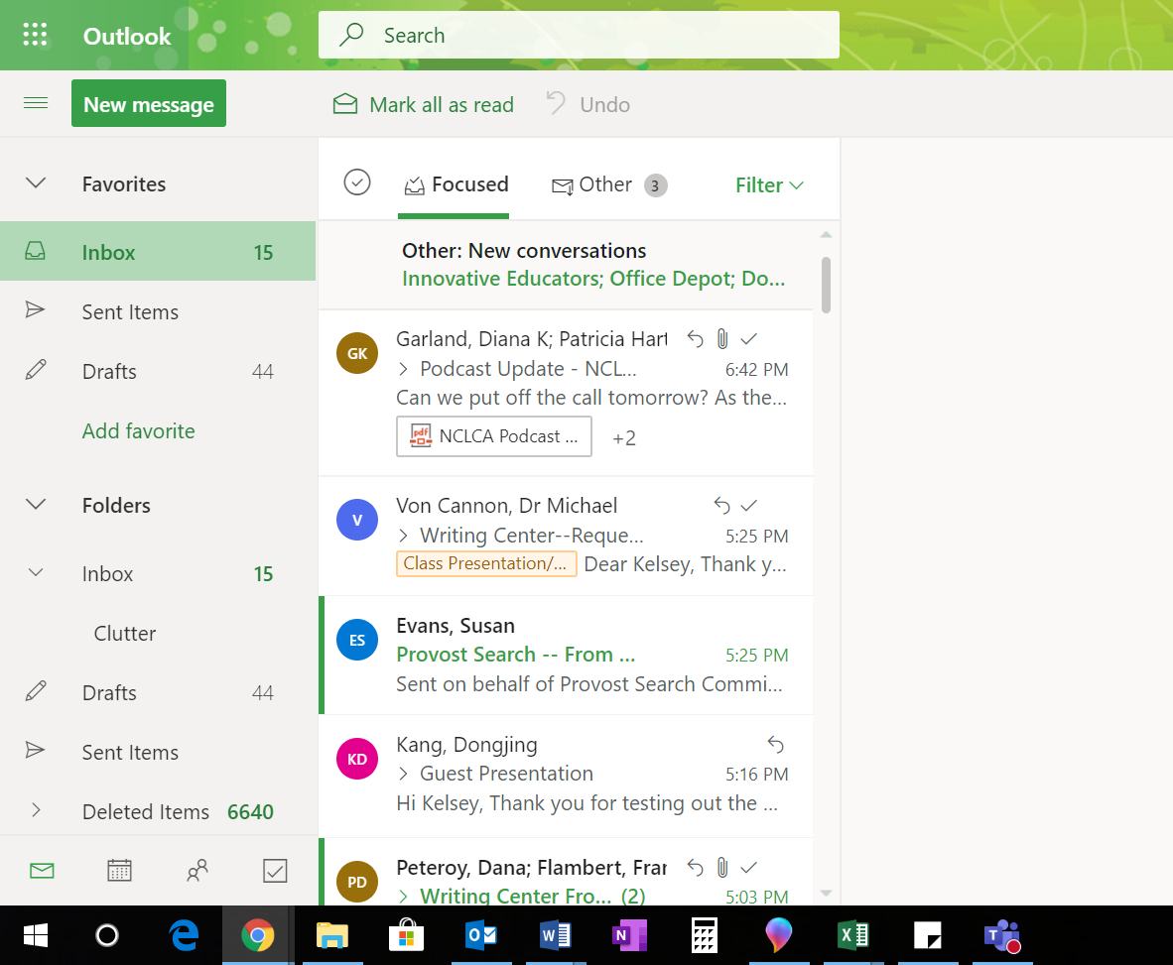

Step 3: Click the Apps selection button, which will open the Microsoft Apps menu
Step 4: Click on “Teams”

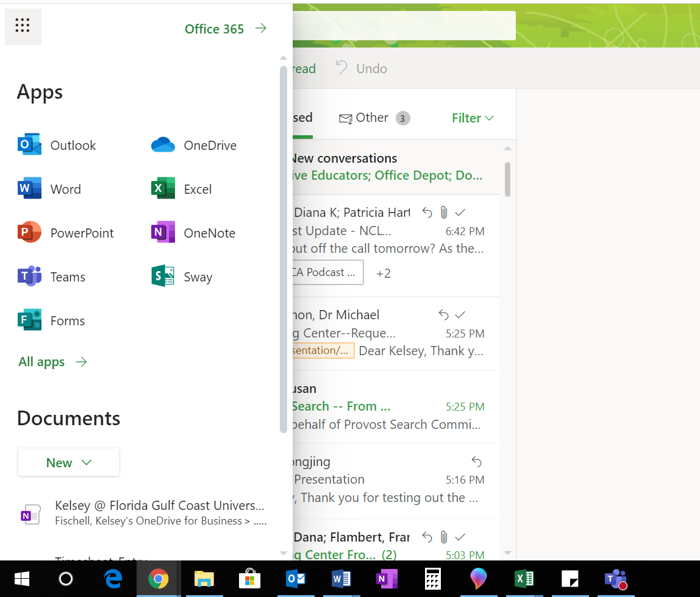

Step 5: The Teams application will open in your browser window.

Step 6: On the left-hand menu, go down to the image of a screen with a downward pointing arrow. This button will give you the option to download teams to your desktop. After clicking this button, follow your computer’s normal process for downloading content.
